

KG ERP USER MANUAL

Prepared by: IT Department, Krishibid Group

Content

Introduction 3

Description of the System 3

1. Dashboard 4

1.1 ERP Login Page 4

1.2 ERP Home Page 5

2. Setting (Feed) 6

2.1 Product Category 6

2.2 Product Sub Category 7

2.3 Product 8

2.4 Product Sale Price 9

2.5 RM Category 10

2.6 RM Sub Category 11

2.7 Raw Material 12

2.8 Feed Formula 13

2.9 District 14

2.10 Upazila 15

2.11 Assign Area 16

2.12 Customers 16

2.13 Suppliers 17

3. Sales & Distribution (Feed) 18

3.1 RM Purchase Demand 18

3.2 Purchase Order 19

3.3 RM Receive 20

3.4 Production Requisition 21

3.5 Production Deliver 22

3.6 Production Issue 23

3.7 Order 23

3.8 Production Deliver 24

3.9 Customer Payments 25

3.10 Product Receive 26

3.11 Finish Products Stock 27

3.12 RM Current Stock 27

3.13 Customers Accounts 28

3.14 Sales Return 28

3.15 Stock Transfer 29

1
User Manual for Krishibid Group ERP (Feed Inventory) 04/3/20

3.16 Stock Receive 30

3.17 Product Receive for Opening 31

CONFIDENTIALITY NOTICE
This documentation is proprietary information of a KRISHIBID GROUP and is not to be copied, reproduced, lent or disposed of, nor used for any purpose other than that for which it is specifically provided without the written permission of Krishibid Group.

©2019 KRISHIBID GROUP ERP all rights reserved. The unauthorized possession, use, reproduction, distribution, display or disclosure of this material or the information contained herein is prohibited.

 | KRISHIBID GROUP ERP
Owner: | KRISHIBID GROUP
Created: | July 30, 2020
Document Type: | Software User Manual Documentation (Krishibid Feed)  (Krishibid Group ERP)
Version: | 1.0 (Start)

Revision information
Rev. | Author | Date | Description
1.0 | Dil Afroza Ahmed Choudhury | March 15, 2020 | Document created

Related documents
Rev. | Document ID | Document name | Comments

2

User Manual for Krishibid Group ERP (Feed Inventory) | 15/3/20

Introduction

The Krishibid Group has initiated development of Enterprise Resource Planning (ERP) with the essence of establishing an effective database, to address and strengthen existing information system through coordinating and networking of existing human resource data collection systems. Krishibid consulted a team of experts, department of IT of Krishibid Group to take the responsibility of developing, implementing and maintaining ERP system in this organization. As for any big system development the process is not an overnight thing. HRMS is evolving, though with a remarkable speed, the inputs of stakeholders are all time required. This manual outlines the systematic procedures for accessing and using various parts of the system.

In case you do not get the assistance, you expected from the manual please consult your system administrator or any person authorized to work as the member of the helpdesk team at your organization.

Description of the System

The following part is intended to give user an insight on how to use the system and access different features and system components.

3

1. Dashboard

1.1 ERP Login Page

Open the browser and type the following address: http:// http://192.168.0.7:90 then a page similar to the one shown in the image below will be displayed whereby a user will be required to type in their correct username and password. This system works best with Google Chrome, Mozilla Firefox, Microsoft Edge or Opera browsers. From here on, the use of the word “browser” will refer to above mentioned web browsers only.
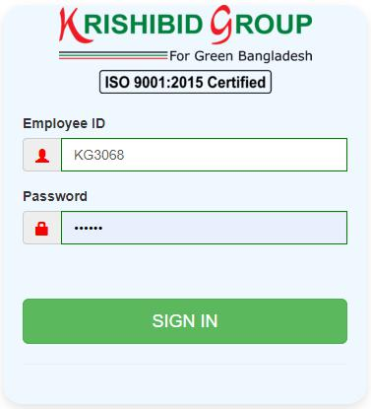

Figure: 01 ERP Login

Logging on ERP System:

- Step-1: Provide Valid Username and Password. For Username Always Provide your

Employee ID. (Example: EmployeeId: KGXXXX, Password: KGXXXX) with UPPERCASE.
- Step-2: Click on ‘Sign In’ button for go to Home page of ERP.

4
User Manual for Krishibid Group ERP (Feed Inventory) | 04/3/20

1.2 ERP Home Page

On successful login, a user is directed to the Home Page which consists of the main menu on the left side named dashboard. At the top most part of the system you will have on your left a home icon to denote the home page, a help button- which contains this help manual and the Employee Id of the user currently accessing the system.

The following figure (Fig-02) shows menu bar and home page.
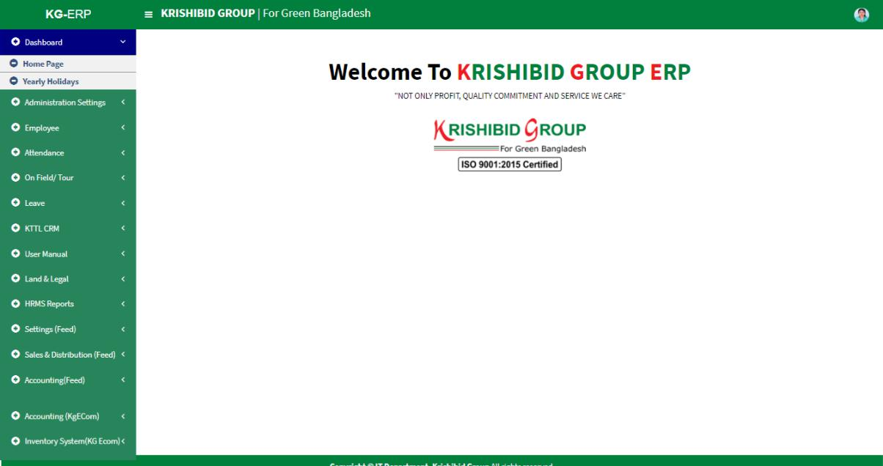

Figure: 02 ERP Home Page

• Step-01: Click on the Dashboard section under main navigation panel of KG ERP.

5
2. Setting (Feed)

2.1 Product Category
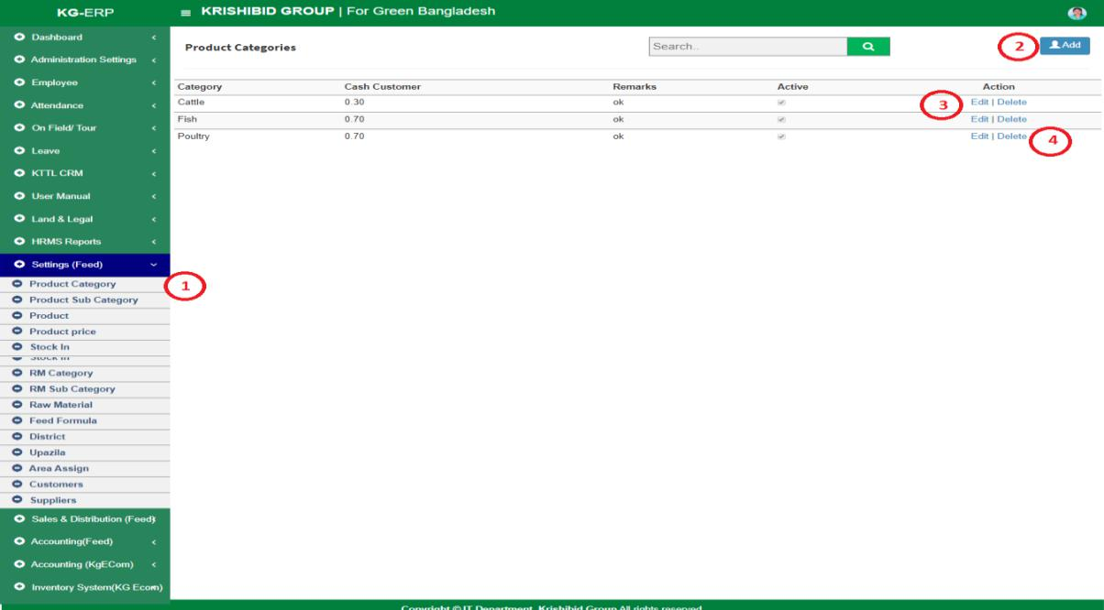

Figure: 03 Product Category

The following figure (Fig-03) shows options for Product Category.

- Step-01: Click on the Product Category section under Settings (Feed) Menu option. The following figure (Fig-03) shows the Product Category of Feed page.
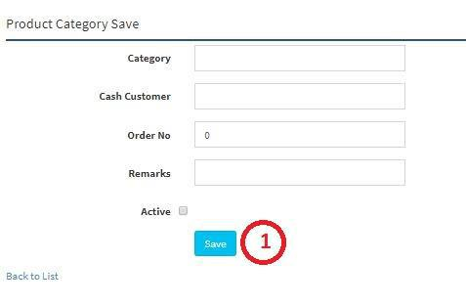

Figure: 04 Product Category Entry Page

- Step-02: Enter any “Date” or “Category” or “Purpose” in the search section and click

“Enter” button to search any product.

6
2.2 Product Sub Category
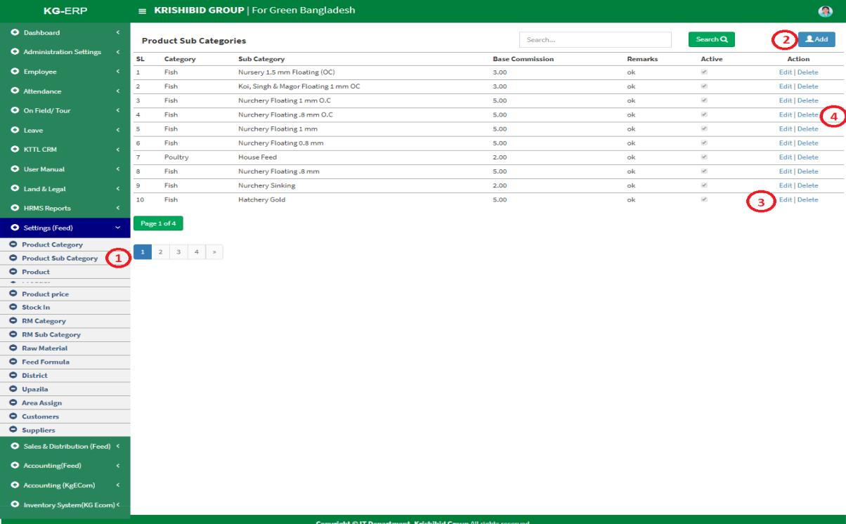

Figure: 05 Product Sub Category

The following figure (Fig-03) shows options for Product Sub Category.

- Step-01: Click on the Product Sub Category section under Settings (Feed) Menu option. The following figure (Fig-03) shows the Product Sub Category of Feed page.

- Step-02: Enter any “Category” or “Sub Category” or “Purpose” in the search section and click “Enter” button to search any product.
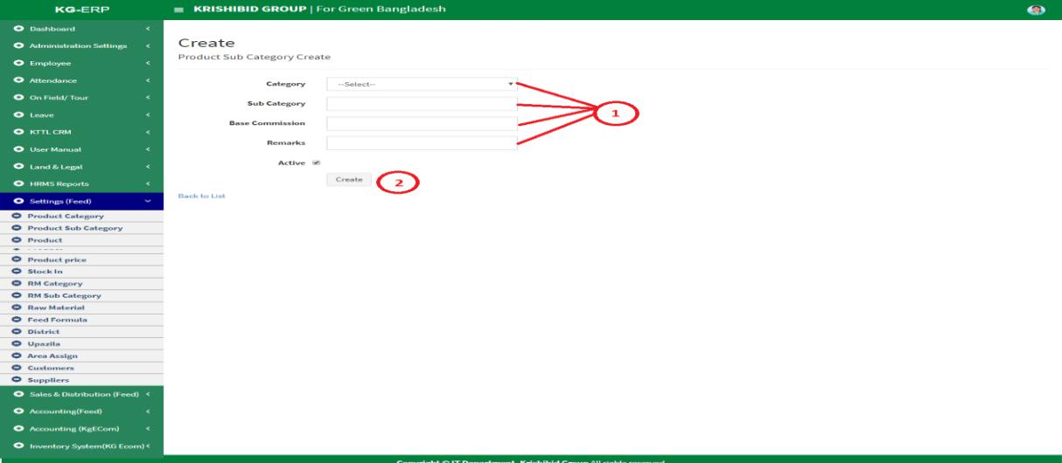

  - Figure: 6 Create Product Sub Category

- Step-01: Enter any “Category”, “Sub Category”, “Base Commission”, Check Active button in the new sub category entry page and click “Create” button to save any new Sub category under the Category.

7
2.3 Product
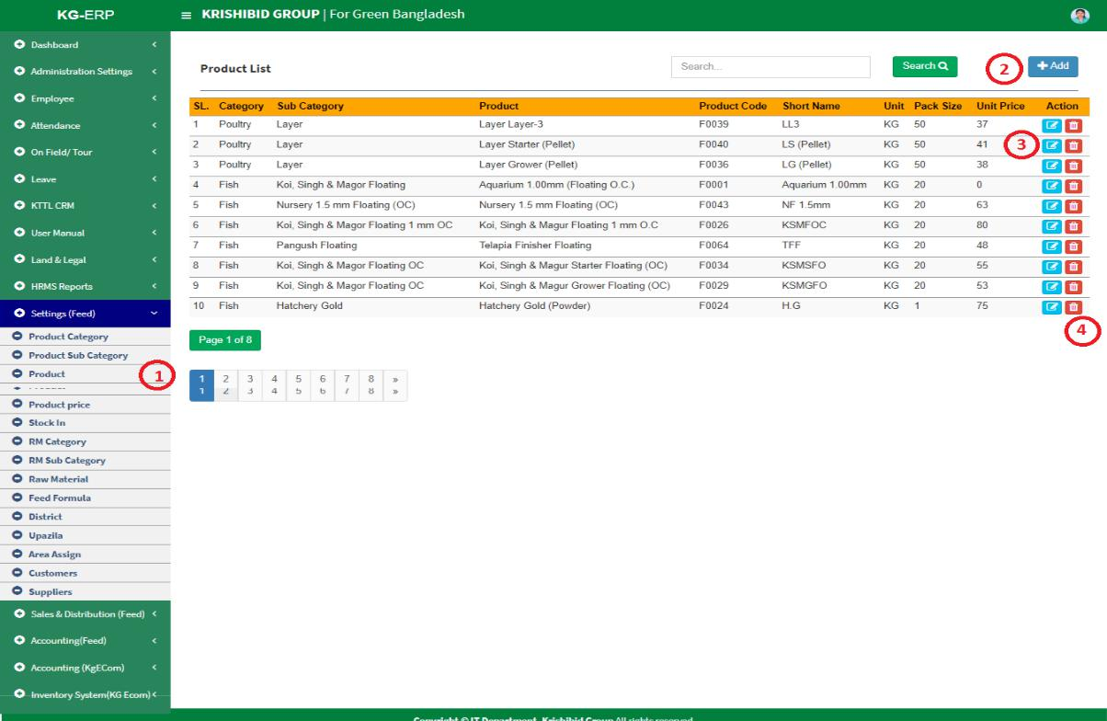

Figure: 7 Product

The following figure (Fig-03) shows options for Product.

- Step-01: Click on the Product section under Settings (Feed) Menu option. The following figure (Fig-03) shows the Product of Feed page.

- Step-02: Enter any “Category” or “Sub Category” or “Product” in the search section and click “Enter” button to search any product.
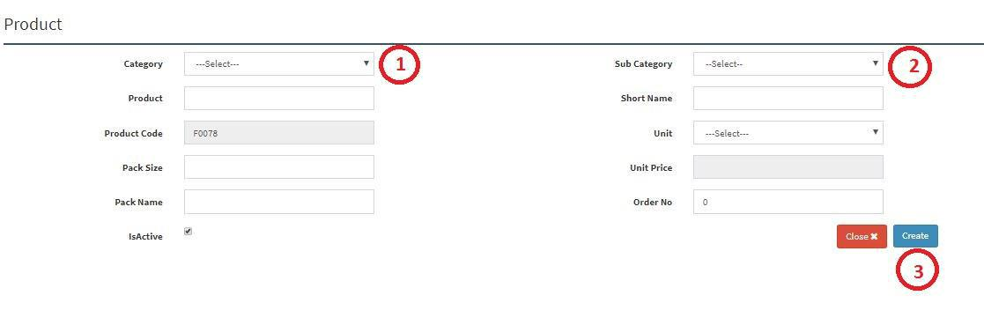

  - Figure: 8 Product Entry Page

- Step-02: Enter ‘Category’, ‘Sub Category’, ‘Product’, ‘Short Name’, ‘Unit’, ‘Pack Size’, ‘Pack Name’, ‘Order No’ and click “Create” button to save any new product.

8

2.4 Product Sale Price
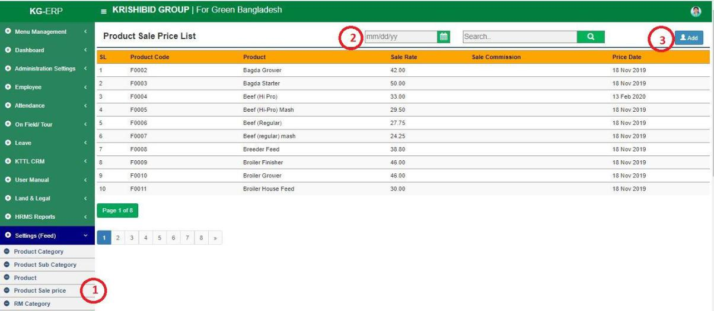

Figure: 9 Product Sale Price

The following figure (Fig-03) shows options for Product Sale Price.

- Step-01: Click on the Product Sale Price section under Settings (Feed) Menu option. The following figure (Fig-03) shows the Product of Feed page.

- Step-02: Enter any “Date” or “Product” in the search section and click “Enter” button to search any products Sale price.
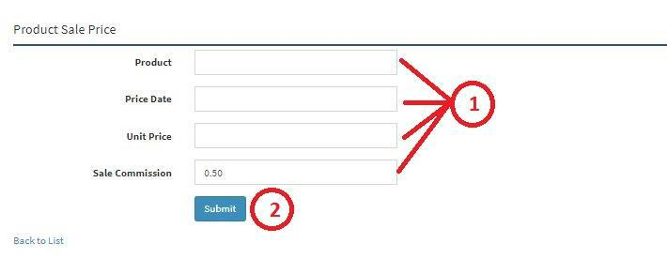

  - Figure: 10 Product Sale Price Entry Page

- Step-02: Enter ‘Product’, ‘Price Date’, ‘Unit Price’, ‘Sale Commission’ and click “Submit” button to save any new Product Sale Price.

9
2.5 RM Category
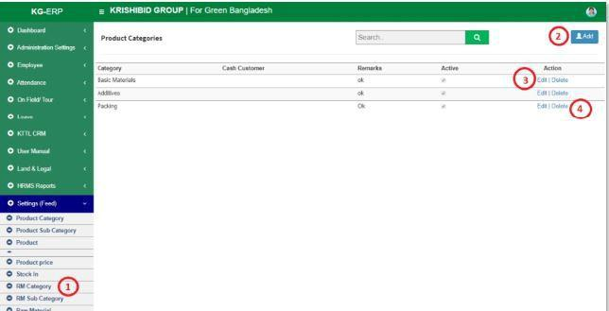

Figure: 11 RM Category

The following figure (Fig-03) shows options for RM Category.

- Step-01: Click on the RM Category section under Settings (Feed) Menu option. The following figure (Fig-03) shows the Product of Feed page.

- Step-02: Enter any “Date” or “Product” in the search section and click “Enter” button to search any new RM Category.
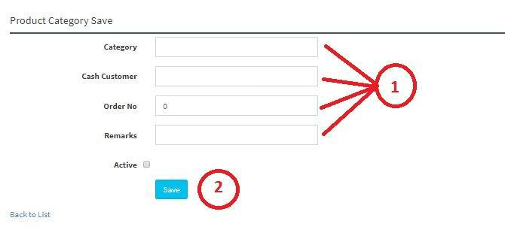

  - Figure: 12 RM Category Entry Page

- Step-02: Enter ‘Category’, ‘Cash Customer’, ‘Order No’, ‘Remarks’ (If Any) and click “Save” button to save any new RM Category.

10

2.6 RM Sub Category
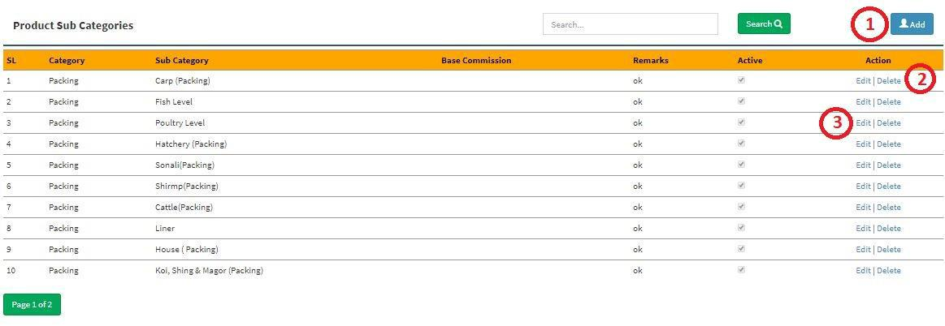

Figure: 13 RM Sub Category

The following figure (Fig-03) shows options for RM Sub Category.

- Step-01: Click on the RM Sub Category section under Settings (Feed) Menu option. The following figure (Fig-03) shows the Product of Feed page.

- Step-02: Enter any “Category”, ‘Sub Category’ or “Base Commission” in the search section and click “Enter” button to search any products Sale price.

- Step-03:
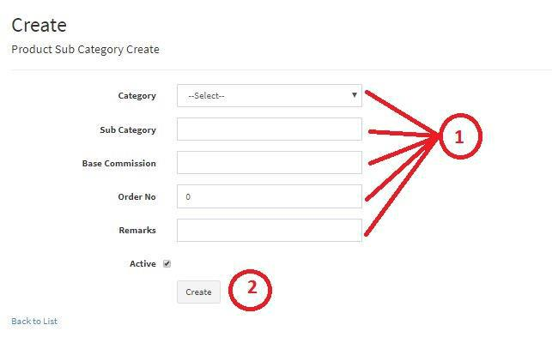

  - Figure: 14 RM Sub Category Entry Page

- Step-02: Enter ‘Category’, ‘Sub Category’, ‘Base Commission’, ‘Order No’, ‘Remarks’ (If

Any) and click “Create” button to save any new Product Sub Category.

11
2.7 Raw Material
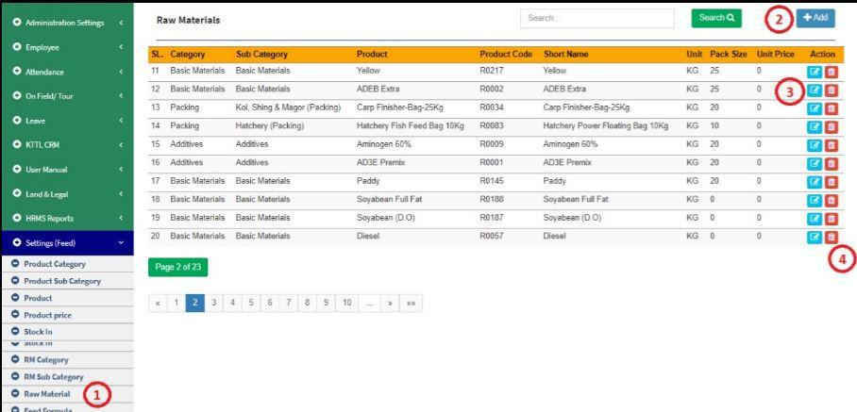

Figure: 15 Raw Material

The following figure (Fig-03) shows options for RM Category.

- Step-01: Click on the Raw Material section under Settings (Feed) Menu option. The following figure (Fig-03) shows the Product of Feed page.

- Step-02: Enter any “Category”, “Sub Category”, “Product”, “Product Code” or “Short Name” in the search section and click “Enter” button to search any Raw Materials.

- Step-03: Click on Edit and Delete Button to update or delete any Raw Material.
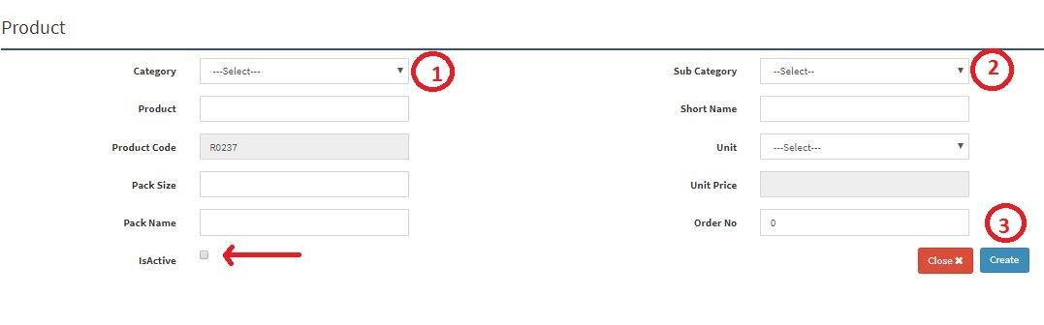

Figure: 16 Raw Material Entry Page

- Step-02: Enter ‘Category’, ‘Sub Category’, ‘Product’, ‘Short Name’, ‘Pack Size’, ‘Pack Name’, ‘Order Name’, must be click on Active button and click “Submit” button to save any new

Raw Material.

12
2.8 Feed Formula
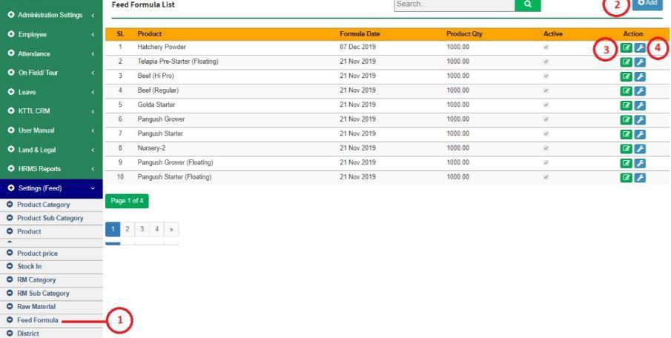

Figure: 17 Feed Formula

The following figure (Fig-03) shows options for RM Category.

- Step-01: Click on the Feed Formula section under Settings (Feed) Menu option. The following figure (Fig-03) shows the Product of Feed page.

- Step-02: Enter any “Formula Date” or “Product” in the search section and click “Enter” button to search any Products Feed Formula. Click on Edit and Delete Button to update or delete any feed formula.
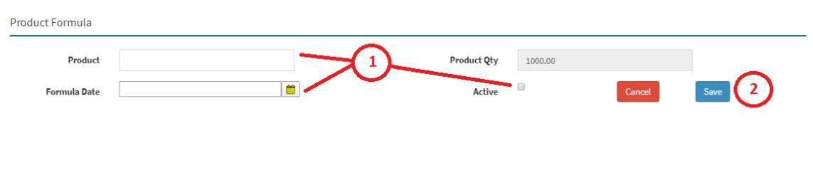

Figure: 18 Feed Formula Entry Page

- Step-01: Enter ‘Product’, ‘Formula Date’, Click on Active Button then click on “Submit” button to save any new Feed Formula.

13
2.9 District
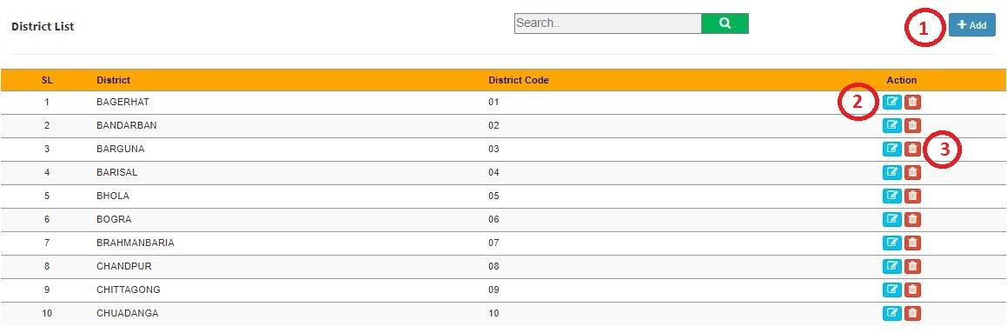

Figure: 19 District

The following figure (Fig-03) shows options for District.

- Step-01: Click on the District section under Settings (Feed) Menu option. The following figure (Fig-03) shows the Product of Feed page.

- Step-02: Enter any “District” or “District Code” in the search section and click “Enter” button to search any products Sale price.
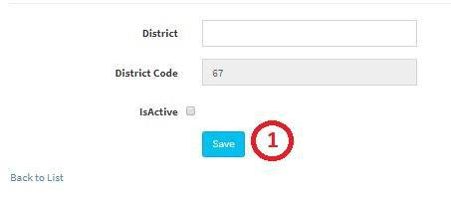

Figure: 20 District Entry Page

- Step-02: Enter ‘District’, ‘Check Active Button’ and click on “Save” button to save any new

District. Must be click on Active button.

14

2.10 Upazila
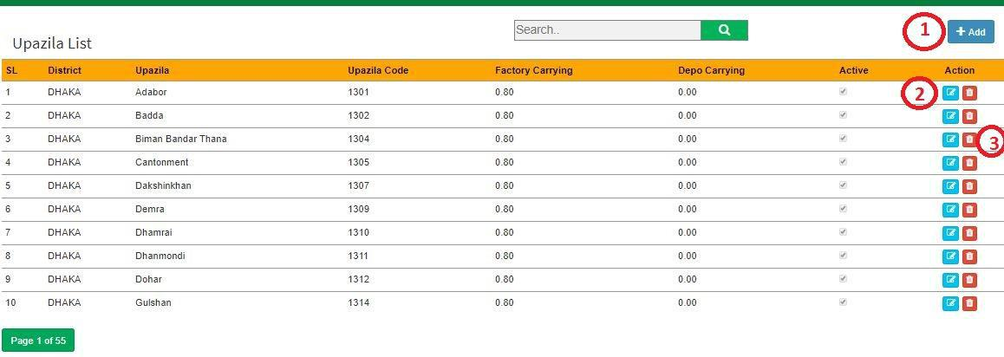

Figure: 21 Upazila

The following figure (Fig-03) shows options for RM Category.

- Step-01: Click on the Upazila section under Settings (Feed) Menu option. The following figure (Fig-03) shows the Product of Feed page.

- Step-02: Enter any “District” or “Upazila” or “Upazila Code” in the search section and click “Enter” button to search any Upazila. Click on Edit and Delete Button to update or delete any Upazila
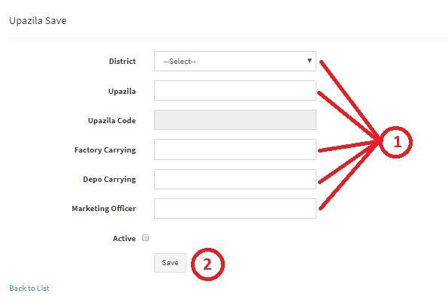

Figure: 22 Upazila Entry Page

- Step-02: Enter ‘District, ‘Upazila’, ‘Factory Carrying Cost’, ‘Depot Carrying’, ‘Marketing Officer’ and click “Submit” button to save any new Upazila. Must be click on Active button.

15

2.11 Assign Area
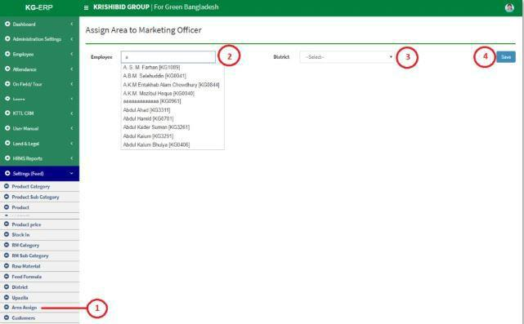

Figure: 23 Area Assign to Marketing Officer

The following figure (Fig-03) shows options for RM Category.

- Step-01: Click on the Area Assign section under Settings (Feed) Menu option. The following figure (Fig-03) shows the Product of Feed page.

- Step-02: Enter “Employee”, “District” click on save button to save any New Assigned Area to any Marketing Officer.

•

2.12 Customers
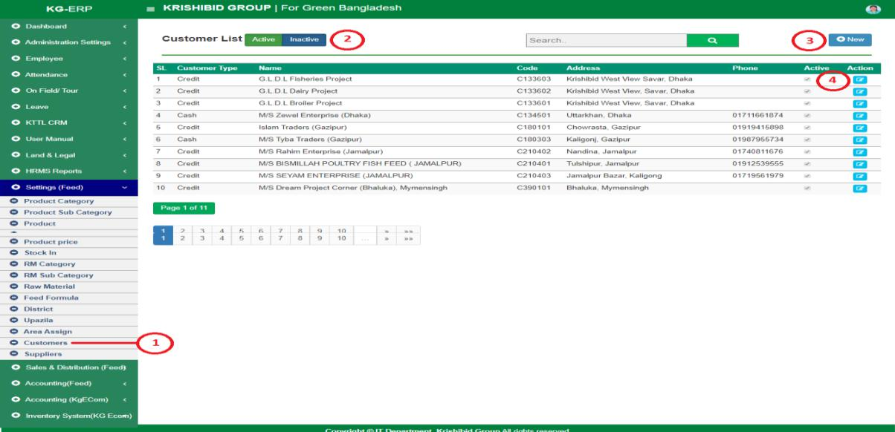

Figure: 24 Customers

The following figure (Fig-03) shows options for RM Category.

- Step-01: Click on the Customers section under Settings (Feed) Menu option. The following figure (Fig-03) shows the Product of Feed page.

16

- Step-02: Enter any “Customer Type” or “Name” in the search section and click “Enter” button to search any products Sale price. Must be click on Active button. Click on Edit and Delete Button to update or delete any Customer.
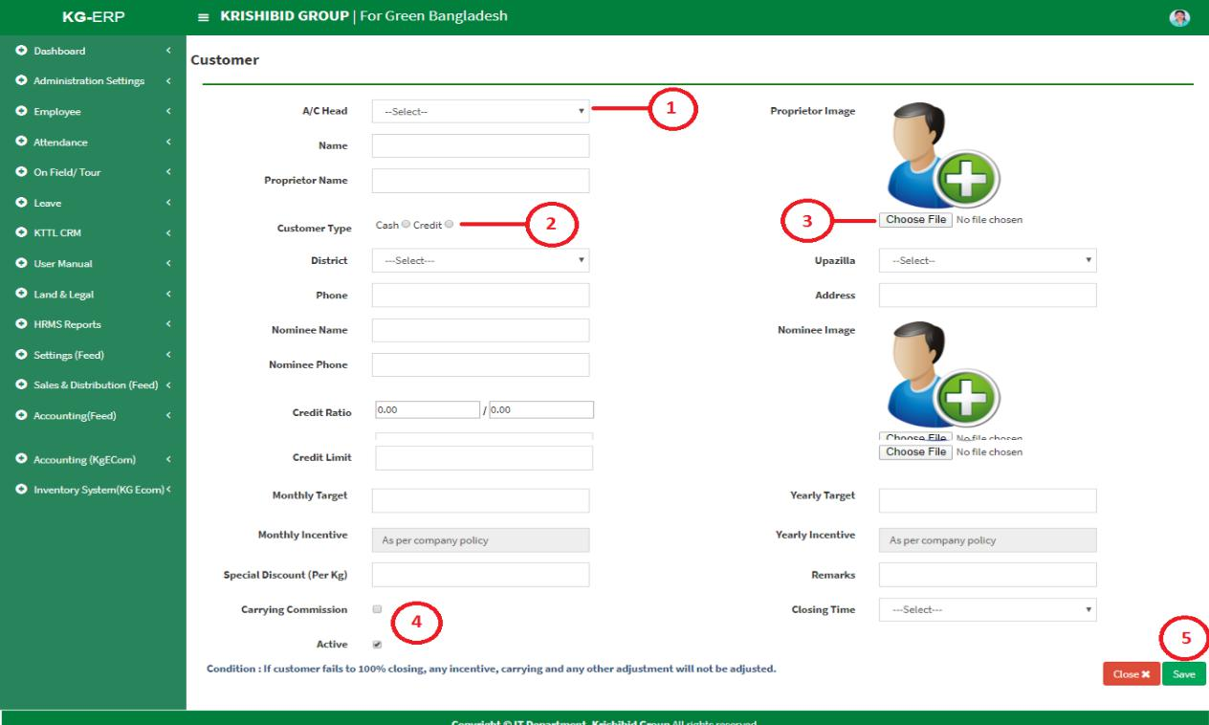

Figure: 25 Customer Entry Page

- Step-02: Enter ‘A/C Head, ‘Name’, ‘Proprietor Name’, ‘Proprietor Image, ‘Customer Type’, ‘District’, ‘Upazila’, ‘Phone’, ‘Address’, ‘Nominee Name’, ‘Nominee Image’, ‘Nominee Phone’, ‘Credit Ratio’, ‘Credit Unit’, ‘Credit Unit’, ‘Monthly Target’, ‘Yearly Target’, ‘Special Discount’, ‘Remarks’, ‘Carrying , ‘Closing Time’ and click “Save” button to save any new
Customer.

2.13 Suppliers
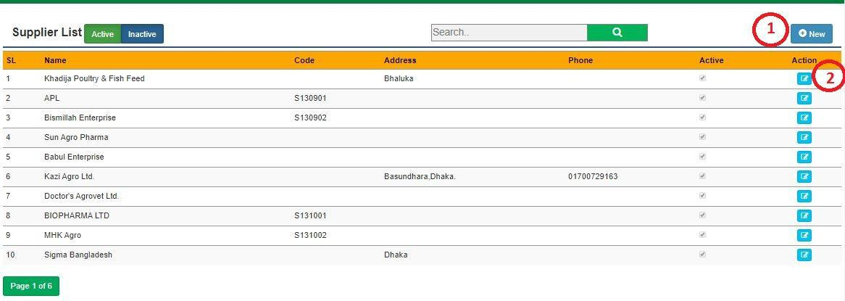

Figure: 26 Suppliers

The following figure (Fig-03) shows options for RM Category.

17
- Step-01: Click on the Supplier section under Settings (Feed) Menu option. The following figure (Fig-03) shows the Product of Feed page.

- Step-02: Enter any “Name” or “Code” in the search section and click “Enter” button to search any products Supplier. Click on Edit and Delete Button to update or delete any Supplier.
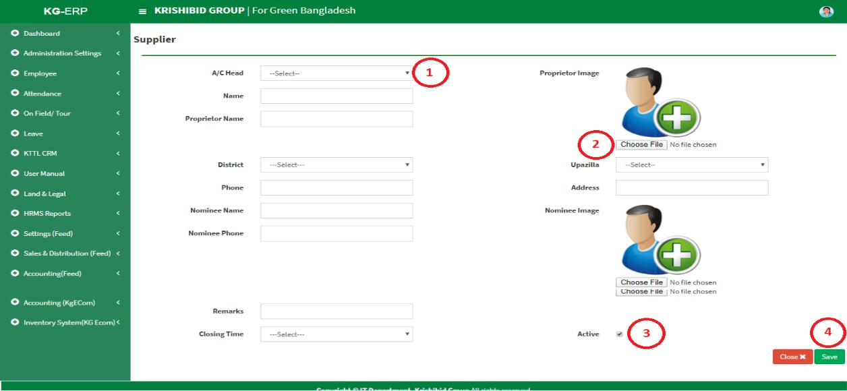

Figure: 27 Suppliers Entry Page

  - Enter ‘A/C Head, ‘Name’, ‘Proprietor Name’, ‘Proprietor Image, ‘Customer Type’, ‘District’, ‘Upazila’, ‘Phone’, ‘Address’, ‘Nominee Name’, ‘Nominee Image’, ‘Nominee Phone’ ‘Remarks’, ‘Closing Time’ and click “Save” button to save any new Supplier.

- Sales & Distribution (Feed)

3.1 RM Purchase Demand
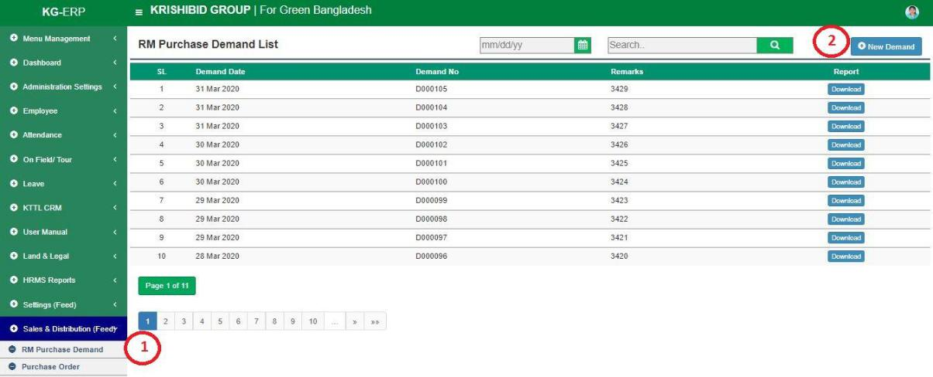

Figure: 28 RM Purchase Demand

The following figure (Fig-03) shows options for RM Purchase Demand.

18
- Step-01: Click on the RM Purchase Demand section under Settings (Feed) Menu option. The following figure (Fig-28) shows the Product of Feed page.

- Step-02: Enter any “Demand Date” or “Demand No” in the search section and click “Enter”
button to search any products Demand. Click on “ | New Demand | ” | Button
to add any new Purchase Demand.
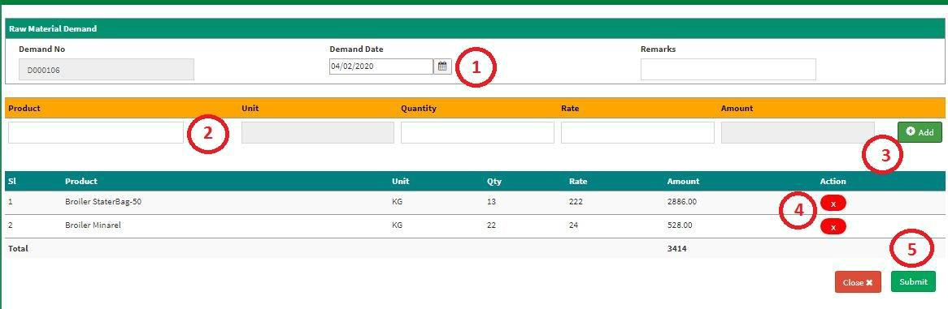

Figure: 29 RM Purchase Demand Entry Page

• Enter ‘Demand Date’, ‘Remarks’, ‘Product’, ‘Quantity’, ‘Rate’ and click “Add” button to add multiple product in list. User may delete individual item on adding list and Click on Submit button to save any new RM Purchase Demand.

3.2 Purchase Order
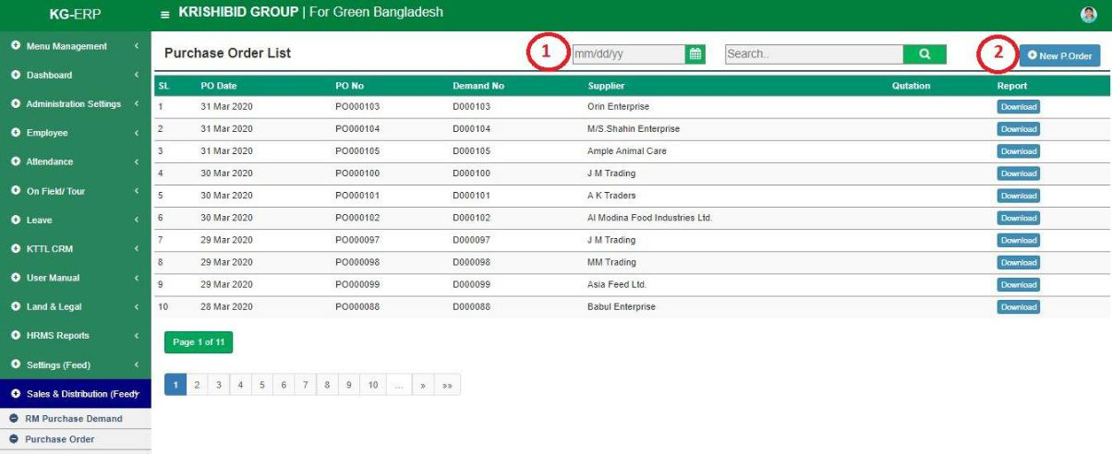

Figure: 30 Purchase Order

The following figure (Fig-30) shows options for Purchase Order.

- Step-01: Click on the Purchase Order section under Settings (Feed) Menu option. The following figure (Fig-28) shows the Product of Feed page.

19

- Step-02: Enter any “PO section and click “Enter” add any new PO Order.

Date” or “PO No” or “Demand No” or “Supplier” in the search button to search any PO Order. Click on “New PO Order” Button to
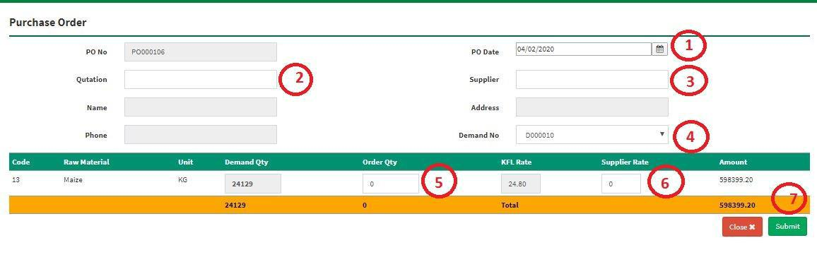

Figure: 31 PO Order Entry Page

- Enter ‘PO Date’, ‘Quotation, ‘Supplier, ‘Demand No, ‘Order Quantity’, ‘Supplier Rate’ and Click on Submit button to save any new Purchase Order.

3.3 RM Receive
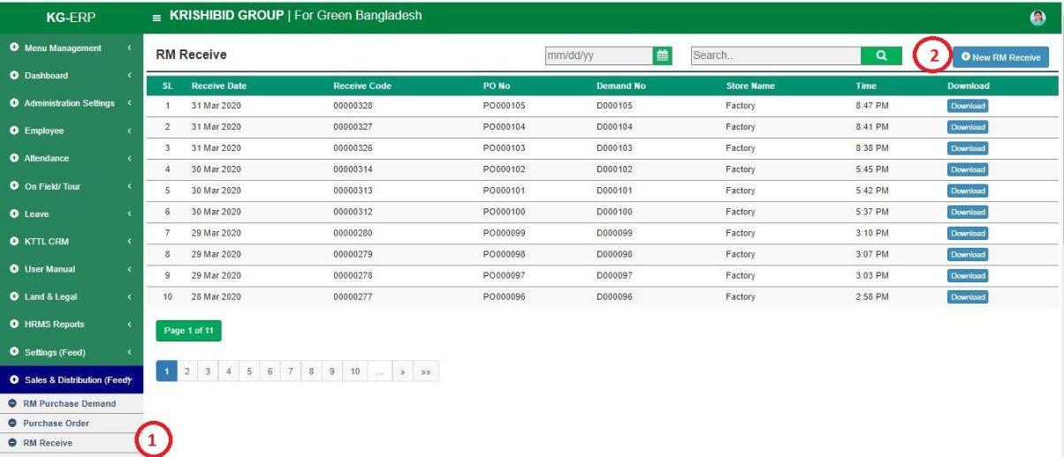

Figure: 32 RM Receive

The following figure (Fig-32) shows options for Purchase Order.

- Step-01: Click on the RM Receive section under Settings (Feed) Menu option. The following figure (Fig-28) shows the Product of Feed page.

- Step-02: Enter any “Receive Code” or “PO No” or “Demand No” or “Store Name” in the search section and click Enter button to search any New RM Receive. Click on “New RM Receive” Button to add any new RM Receive.

20

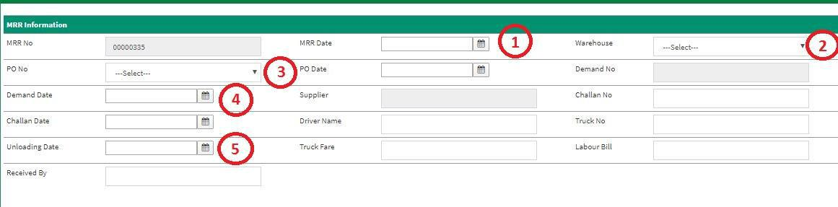

Figure: 33 RM Receive Entry Page

- Enter ‘MRR Date’, ‘Ware House, ‘PO Date, ‘Demand Date, ‘Challan No’, ‘Challan Date’, ‘Driver Name’, ‘Truck No’, ‘Uploading Date’, ‘Truck Fare’, ‘Labour Bill’, ‘Received By’ and Click on Submit button to save any new RM Receive.

3.4 Production Requisition
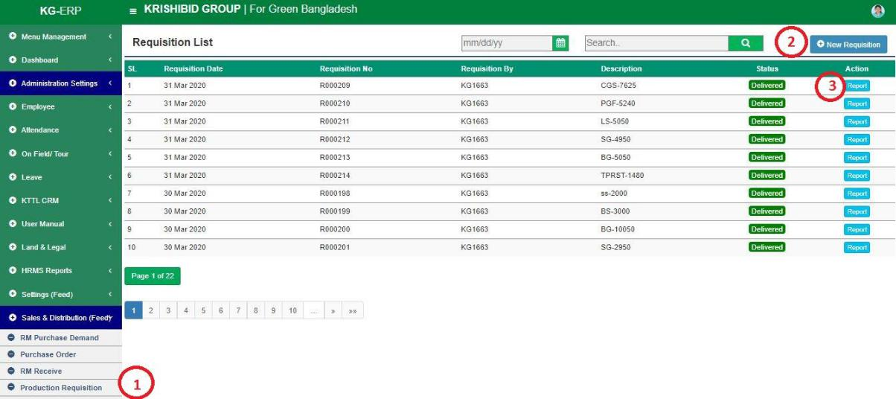

Figure: 34 Production Requisition

The following figure (Fig-34) shows options for Production Requisition.

- Step-01: Click on the Production Requisition section under Settings (Feed) Menu option. The following figure (Fig-28) shows the Product of Feed page.

- Step-02: Enter any “Requisition Date” or “Requisition No” or “Received By” or “Store Name” in the search section and click “Enter” button to search any Requisition. Click on “New Requisition” Button to add any new Requisition.

21
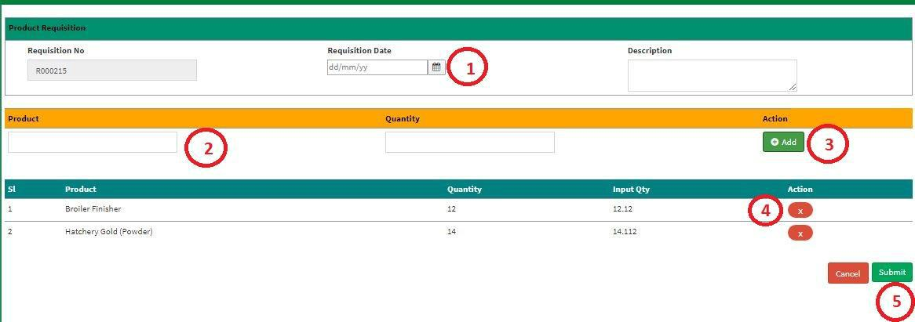

Figure: 35 Product Requisition Entry Page

- Enter ‘Requisition Date’, ‘Description, ‘Product, ‘Quantity’ click on Add button to load multiple Item on list and Click on Submit button to save any new Product Requisition.

3.5 Production Deliver
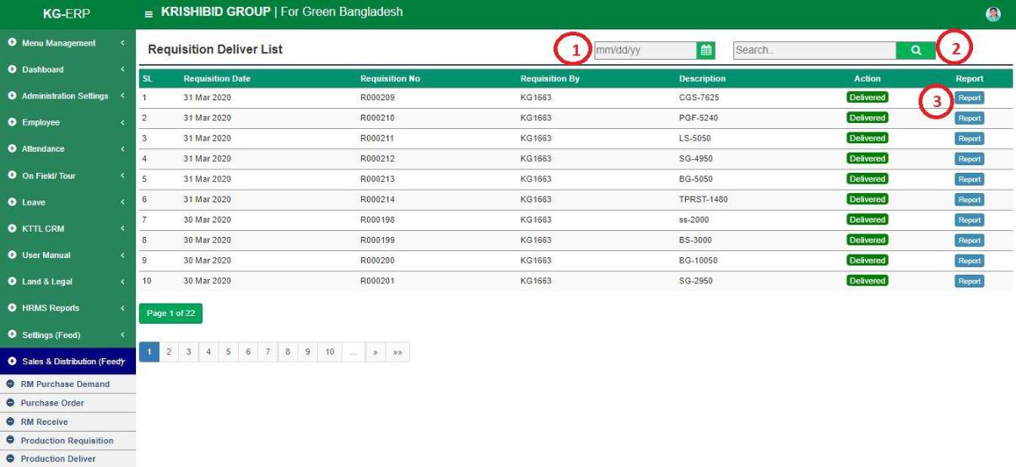

Figure: 36 Production Deliver

The following figure (Fig-36) shows options for Production Requisition.

- Step-01: Click on the Production Requisition section under Settings (Feed) Menu option. The following figure (Fig-28) shows the Product of Feed page.

- Step-02: Enter any “Requisition Date” or “Requisition No” or “Received By” or “Store

Name” in the search section and click “Enter” button to search any Delivered product. Click on Report button to view date wise delivery report.

22

3.6 Production Issue
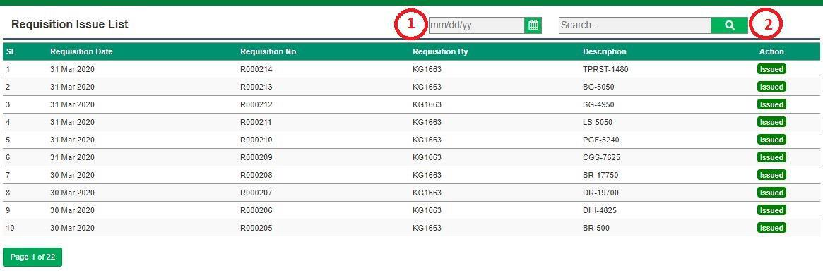

Figure: 37 Production Issue

The following figure (Fig-37) shows options for Production Issue.

- Step-01: Click on the Production Issue section under Settings (Feed) Menu option. The following figure (Fig-28) shows the Product of Feed page.

- Step-02: Enter any “Requisition Date” or “Requisition No” or “Received By” or “Store Name” in the search section and click “Enter” button to search any Requisition. Click on Issue button to view date wise issued requisition.

3.7 Order
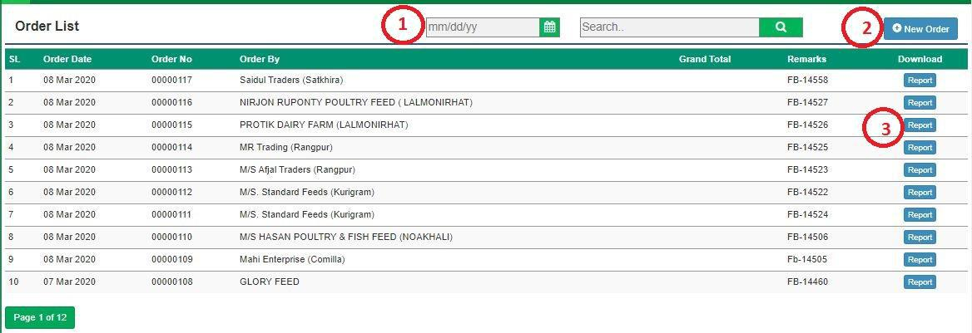

Figure: 38 Production Requisition

The following figure (Fig-38) shows options for Production Requisition.

- Step-01: Click on the Production Requisition section under Settings (Feed) Menu option. The following figure (Fig-28) shows the Product of Feed page.

- Step-02: Enter any “Requisition Date” or “Requisition No” or “Received By” or “Store Name” in the search section and click “Enter” button to search any Requisition. Click on “New Requisition” Button to add any new Requisition.

23
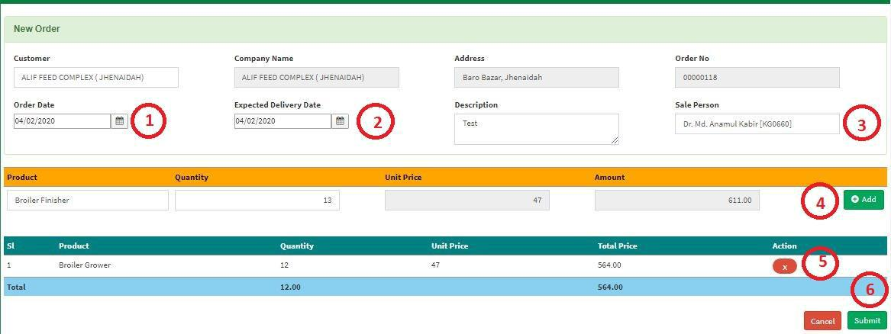

Figure: 39 Product Order Entry Page

- Enter ‘Customer, ‘Order Date, ‘Expected Delivery Date, ‘Description’, ‘Sale Person’, ‘Product’, ‘Quantity’ click on Add button to load multiple Item on list and Click on Submit button to save any new Product Requisition.

3.8 Production Deliver

Figure: 40 Production Deliver

The following figure (Fig-40) shows options for Production Requisition.

- Step-01: Click on the Production Deliver section under Settings (Feed) Menu option. The following figure (Fig-28) shows the Product of Feed page.

- Step-02: Enter any “Requisition Date” or “Requisition No” or “Received By” or “Store Name” in the search section and click “Enter” button to search any delivered product.

24

3.9 Customer Payments
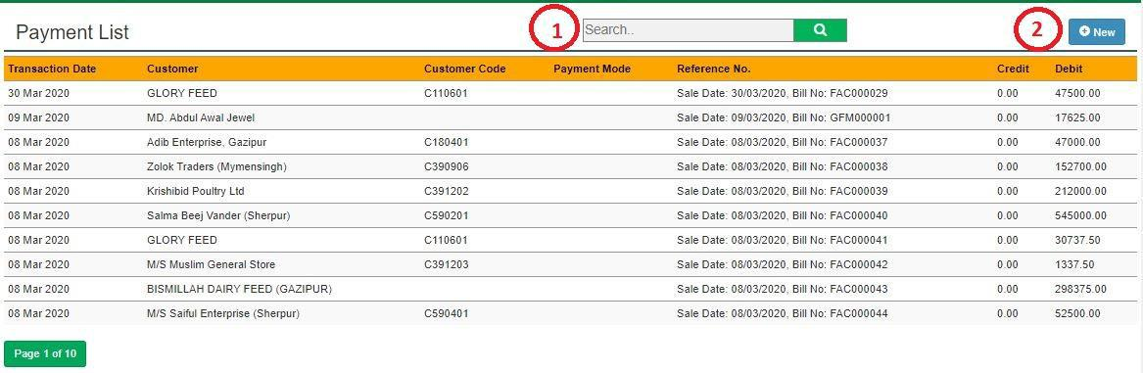

Figure: 41 Customer Payments

The following figure (Fig-41) shows options for Customer Accounts.

- Step-01: Click on the Customer Accounts section under Settings (Feed) Menu option. The following figure (Fig-28) shows the Product of Feed page.

- Step-02: Enter any “Transaction Date” or “Customer” or “Customer Code” or “Reference No” or “Payment Mode” in the search section and click “Enter” button to search any customers account information.

- Click on “New Payment” Button to add any new Customers Payment.
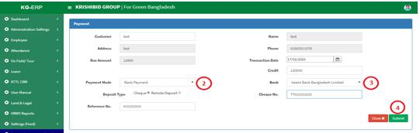

Figure: 39 Customer Payment Entry Page

- Enter ‘Customer, ‘Transaction Date, ‘Payment Method, ‘Credit’, ‘Bank’, ‘Cheque No,

‘Reference No click on Add button to load multiple Item on list and Click on Submit button to save any new Customer Payment.

25

3.10 Product Receive
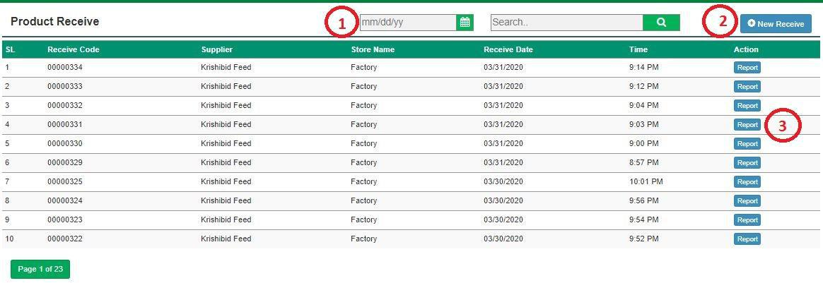

Figure: 42 Product Receive

The following figure (Fig-42) shows options for Product Receive.

- Step-01: Click on the Product Receive section under Settings (Feed) Menu option.

- Step-02: Enter any “Receive Code” or “Supplier” or “Store Name” or “Receive Date” in the search section and click “Enter” button to search any received product. Click on “New Receive” Button to add any new product receive.
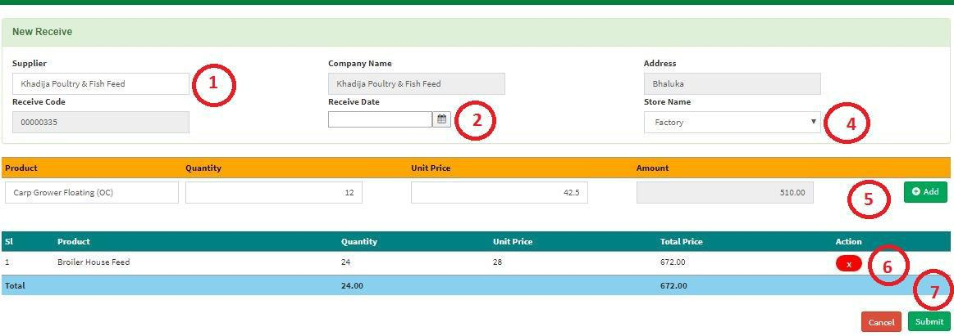

Figure: 43 Product Receive Entry Page

- Enter ‘Supplier, ‘Receive Date, ‘Store Name, ‘Product’, ‘Quantity’ click on Add button to load multiple Item on list and Click on Submit button to save any new Product Requisition.

26

3.11 Finish Products Stock
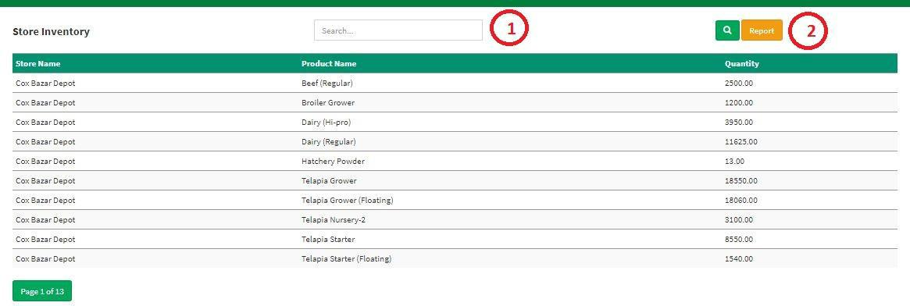

Figure: 44 Finish Product Stock

The following figure (Fig-44) shows options for Finish Product Stock.

- Step-01: Click on the Finish Product Stock section under Settings (Feed) Menu option.

- Step-02: Enter any “Store Name” or “Product Name” or “Quantity” in the search section and click “Enter” button to search any customers account information. Click on Report button for view depot wise all products quantity.

3.12 RM Current Stock
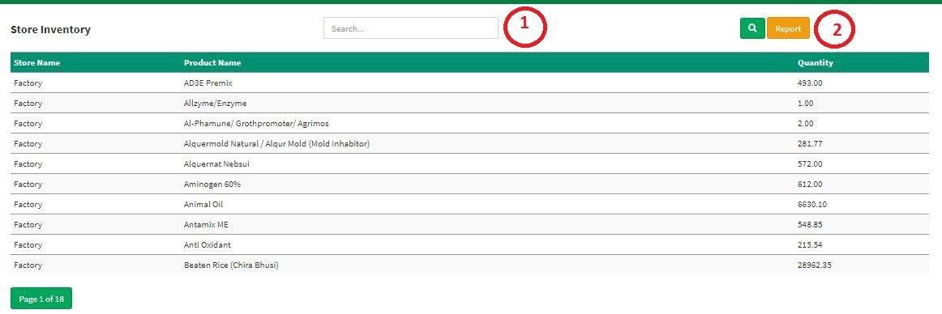

Figure: 45 RM Current Stock

The following figure (Fig-45) shows options for RM Current Stock.

- Step-01: Click on the RM Current Stock section under Settings (Feed) Menu option.

- Step-02: Enter any “Store Name” or “Product Name” or “Quantity” in the search section and click “Enter” button to search any customers account information. Click on Report button for view depot wise all raw materials quantity.

27

3.13 Customers Accounts
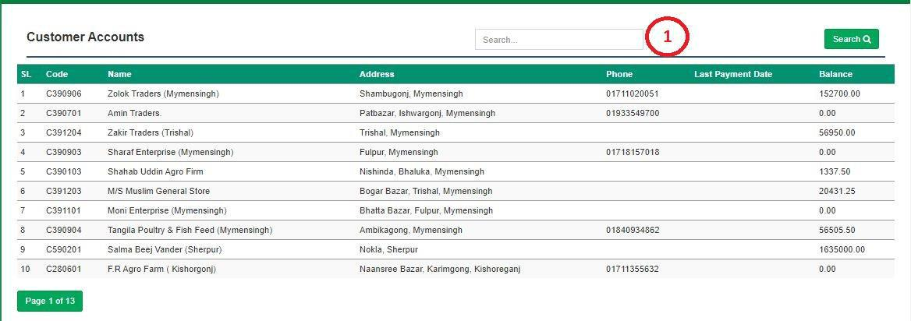

Figure: 46 Customers Accounts

The following figure (Fig-45) shows options for Customer Accounts.

- Step-01: Click on the Customer Accounts section under Settings (Feed) Menu option.

- Step-02: Enter any “Code” or “Name” or “Address” or “Phone” in the search section and click “Enter” button to search any individual customers account status.

3.14 Sales Return
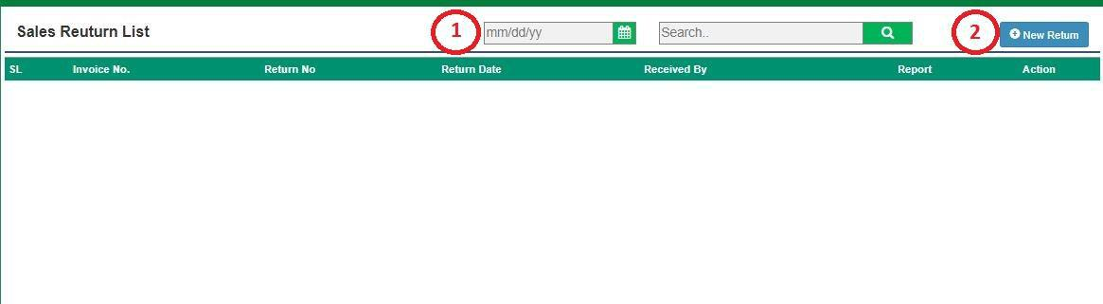

Figure: 47 Sales Return

The following figure (Fig-47) shows options for Sales Return.

- Step-01: Click on the Sales Return section under Settings (Feed) Menu option.

- Step-02: Enter any “Invoice No” or “Return No” or “Return Date” or “Received by” in the search section and click “Enter” button to search any received product. Click on “New Return” Button to add any new product return.

28
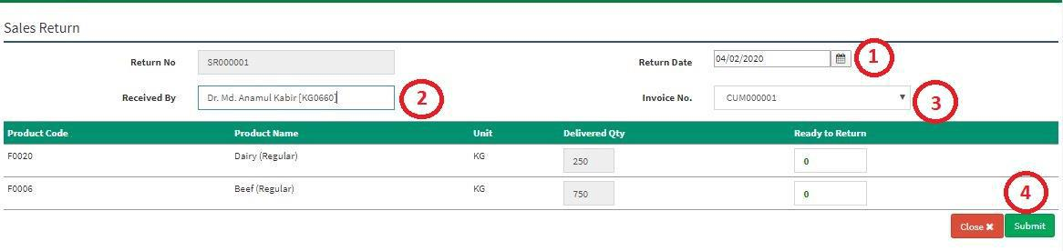

Figure: 48 Sales Return Entry Page

- Enter ‘Supplier, ‘Return Date, ‘Received By, ‘Invoice No’, ‘Unit’, ‘Ready to Return’ click on

Add button to load multiple Item on list and Click on Submit button to save any new Sales Return.

3.15 Stock Transfer
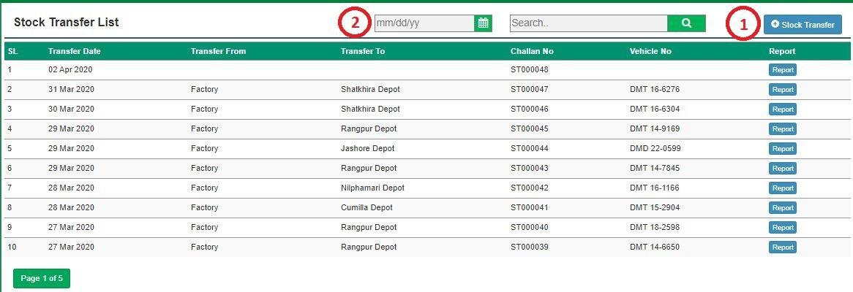

Figure: 49 Stock Transfer

The following figure (Fig-47) shows options for Stock Transfer.

- Step-01: Click on the Stock Transfer section under Settings (Feed) Menu option.

- Step-02: Enter any “Transfer Date” or “Transfer From” or “Transfer To” or “Challan No” or “Vehicle No” in the search section and click “Enter” button to search any received product. Click on “New Transfer” Button to add any new product transfer.
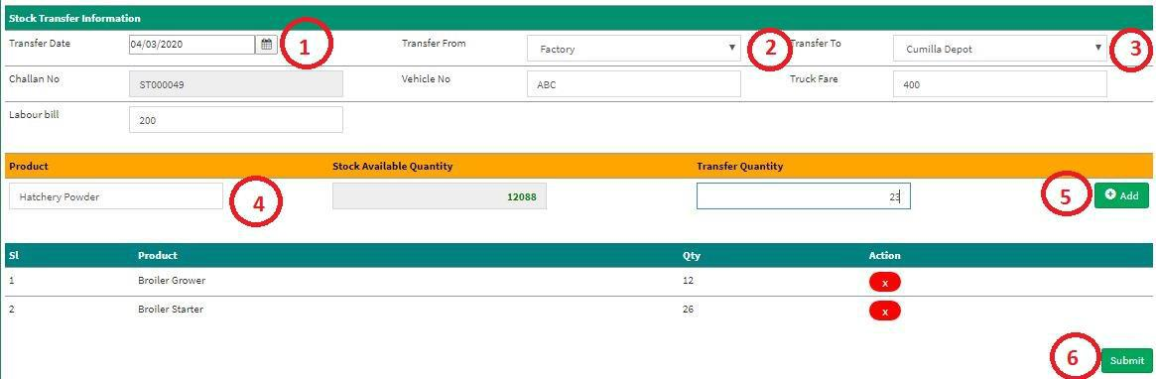

Figure: 48 Sales Return Entry Page

- Enter ‘Transfer Date, ‘Transfer From, ‘Transfer To, ‘Vehicle No, ‘Truck Fare, ‘Labour Bill’, ‘Product’, ‘Transfer Quantity’ click on Add button to load multiple Item on list and Click on Submit button to save any new Product Transfer.

29

3.16 Stock Receive
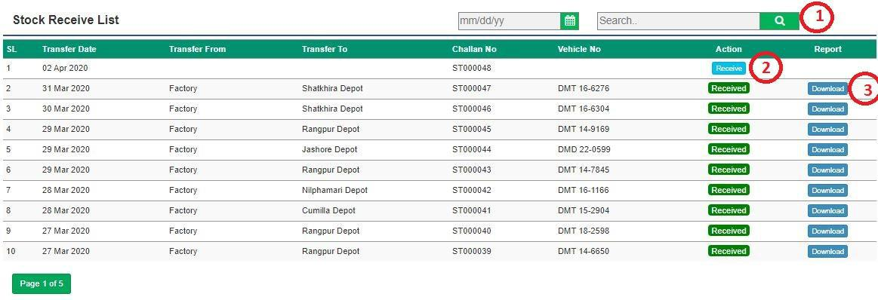

Figure: 49 Stock Receive

The following figure (Fig-47) shows options for Stock Transfer.

- Step-01: Click on the Stock Transfer section under Settings (Feed) Menu option.

- Step-02: Enter any “Transfer Date” or “Transfer From” or “Transfer To” or “Challan No” or “Vehicle No” in the search section and click “Enter” button to search any received product.

Figure: 50 Stock Receive Entry Page

- Enter ‘Transfer Date, ‘Transfer From, ‘Transfer To, ‘Vehicle No, ‘Truck Fare, ‘Labour Bill’, ‘Product’, ‘Transfer Quantity’ click on Add button to load multiple Item on list and Click on Submit button to save any new Product Transfer.

30

3.17 Product Receive for Opening

Figure: 51 Product Receive for Opening

The following figure (Fig-32) shows options for Product Receive.

- Step-01: Click on the Product Receive section under Settings (Feed) Menu option.

- Step-02: Enter any “Receive Code” or “PO No” or “Demand No” or “Store Name” in the search section and click Enter button to search any New RM Receive. Click on “New Receive” Button to add any new RM Receive.

Figure: 33 Product Receive for Opening Entry Page

- Enter ‘MRR Date’, ‘Ware House, ‘PO Date, ‘Demand Date, ‘Challan No’, ‘Challan Date’,

‘Driver Name’, ‘Truck No’, ‘Uploading Date’, ‘Truck Fare’, ‘Labour Bill’, ‘Received By’ and Click on Submit button to save any new RM Receive.

31

